《计算机视觉》实验报告

# 实验06：图像增强

|  |  |  |  |
| --- | --- | --- | --- |
| 姓名 | 庞晓宇 | 学号 | 2020118100 |
| 实验地点 | 信息学院310 | 实验日期 | 2023年10月13日 |

**一、实验内容**

【1】分别选合适的图片，通过灰度变换、直方图规定化、频域滤波、伪彩色着色等方法进行图像增强。

【2】联合几何变换类和颜色变换类方法，为同一张图片进行数据扩充，要求扩充到30张以上。

【3】选合适的图片，从灰度变换、直方图规定化、空域滤波、频域滤波、同态滤波、伪彩色着色、颜色变换等方法中选择合适的组合联合处理图片，使图片视觉质量得到明显的改善或者呈现出独特的视觉效果。

1. **实验过程以及结果分析**

本次实验选用下面的一些图片： 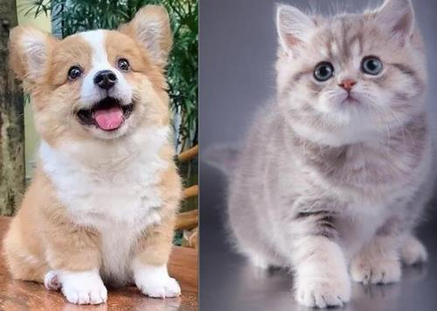  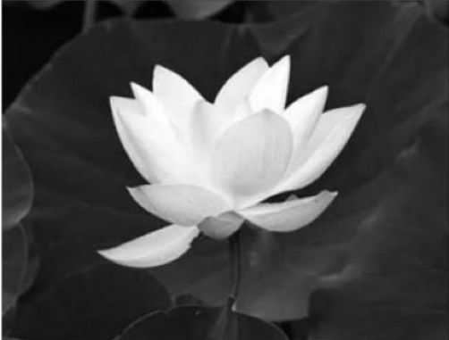

解决了若干报错后的工具函数包：

import matplotlib.pyplot as plt  
import numpy as np  
import cv2  
  
  
# 图像增强  
# 显示概率分布直方图和概率累计图  
def showImgHist(img):  
 fig, axes = plt.subplots(nrows=3, ncols=1, figsize=(4, 4))  
 for c, c_color in enumerate(("b", "g", "r")):  
 i_values, i_counts = np.unique(img[..., c], return_counts=True)  
 i_quantiles = np.cumsum(i_counts.astype(np.float64))  
 i_quantiles /= i_quantiles[-1]  
 axes[c].hist(  
 img[:, :, c].reshape(-1),  
 density=True,  
 bins=256,  
 range=(0, 256),  
 color=c_color,  
 )  
 axTw = axes[c].twinx()  
 axTw.plot(i_values, i_quantiles, color="darkorange") # 'gold'  
 axTw.set_ylim(0, 1.0)  
 axes[c].set_ylabel(c_color)  
 axes[c].set_xlim(0, 256)  
 plt.tight_layout()  
 plt.show()  
 # 可用于各种图像增强处理前后灰度直方图的变化对比  
  
  
# 灰度变换  
# 线性变换  
def TwoSegment0(x, A, B, C):  
 xcp = x.copy(x)  
 xcp = np.where(x <= B, 127.0 * ((x - A) / (B - A + 0.0001)), xcp)  
 xcp = np.where(x > B, 127.0 + 128.0 * ((x - B) / (C - B + 0.0001)), xcp)  
 return np.clip(xcp, 0, 255)  
  
  
def FourSegment0(x, A, B, C):  
 # xcp = x.copy(x)  
 # TypeError: order must be str, not numpy.ndarray  
 xcp = x.copy()  
 xcp = np.where(x <= A, 0.0 + 63.0 * ((x - 0) / (A - 0 + 0.0001)), xcp)  
 xcp = np.where((x > A) & (x <= B), 63.0 + 64.0 * ((x - A) / (B - A + 0.0001)), xcp)  
 xcp = np.where((x > B) & (x <= C), 127.0 + 64.0 * ((x - B) / (C - B + 0.0001)), xcp)  
 xcp = np.where(x > C, 191.0 + 64.0 * ((x - C) / (255 - C + 0.0001)), xcp)  
 return np.clip(xcp, 0, 255)  
  
  
def cvBGRAdjust0(imData, saveName, f=FourSegment0, channel="rgb"):  
 # 定义回调函数，此程序无需回调，所以Pass即可  
 def callback(object):  
 pass  
  
 MAX_VALUE = 255 # 滑动条最大值  
 MIN_VALUE = 0 # 滑动条最小值  
 if f == TwoSegment0:  
 a0, b0, c0 = 0, 127, 255  
 if f == FourSegment0:  
 a0, b0, c0 = 63, 127, 191  
 cv2.namedWindow("cvAdjust", cv2.WINDOW_GUI_NORMAL)  
  
 # cv2.resizeWindow("resized", imData.shape[0], imData.shape[1])  
 # cv2.error: OpenCV(4.8.1) D:\a\opencv-python\opencv-python\opencv\modules\highgui\src\window_w32.cpp:1473: error: (-27:Null pointer) NULL window: 'resized' in function 'cvResizeWindow'  
 cv2.resizeWindow("cvAdjust", imData.shape[1], imData.shape[0])  
 cv2.createTrackbar("a", "cvAdjust", MIN_VALUE, MAX_VALUE, callback)  
 cv2.createTrackbar("b", "cvAdjust", MIN_VALUE, MAX_VALUE, callback)  
 cv2.createTrackbar("c", "cvAdjust", MIN_VALUE, MAX_VALUE, callback)  
 cv2.setTrackbarPos("a", "cvAdjust", a0)  
 cv2.setTrackbarPos("b", "cvAdjust", b0)  
 cv2.setTrackbarPos("c", "cvAdjust", c0)  
 while True:  
 # BGRCopy = np.copy(imData).astype(np.float) # 复制原图  
 # AttributeError: module 'numpy' has no attribute 'float'.  
 # `np.float` was a deprecated alias for the builtin `float`. To avoid this error in existing code, use `float` by itself. Doing this will not modify any behavior and is safe. If you specifically wanted the numpy scalar type, use `np.float64` here.  
 # The aliases was originally deprecated in NumPy 1.20; for more details and guidance see the original release note at:  
 # https://numpy.org/devdocs/release/1.20.0-notes.html#deprecations. Did you mean: 'cfloat'?  
 BGRCopy = np.copy(imData).astype(float)  
 A = cv2.getTrackbarPos("a", "cvAdjust")  
 B = cv2.getTrackbarPos("b", "cvAdjust")  
 C = cv2.getTrackbarPos("c", "cvAdjust")  
 b, g, r = cv2.split(BGRCopy)  
 if "b" in channel:  
 b = f(b, A, B, C)  
 if "g" in channel:  
 g = f(g, A, B, C)  
 if "r" in channel:  
 r = f(r, A, B, C)  
 imBGR = cv2.merge(np.uint8([b, g, r]))  
 cv2.imshow("cvAdjust", imBGR)  
 ch = cv2.waitKey(5) # 按 ESC 退出  
 # if ch == 27 or ch == ord("s") or cv2.getWindowProperty("cvAdjust", 0) == -1:  
 if (  
 ch == 27  
 or ch == ord("s")  
 or cv2.getWindowProperty("cvAdjust", cv2.WND_PROP_VISIBLE) == 0  
 ):  
 cv2.imwrite(saveName + "-Adjusted.jpg", imBGR) # 保存图片并退出  
 break  
 cv2.destroyAllWindows() # 关闭窗口  
  
  
# 非线性变换  
def pow0(x, gamma):  
 return x**gamma  
  
  
def pow1(x, gamma):  
 return 1 - (1 - x) ** gamma  
  
  
def sigmoid0(x, gamma):  
 gamma = gamma + 0.00001  
 return (2 / (1 + np.exp(-gamma * x)) - 1) / (2 / (1 + np.exp(-gamma)) - 1)  
  
  
def sigmoid1(x, gamma):  
 gamma = gamma + 0.00001  
 return 1 - (2 / (1 + np.exp(-gamma * (1 - x))) - 1) / (2 / (1 + np.exp(-gamma)) - 1)  
  
  
def logic0(x, gamma):  
 return 1 - np.log((1 - x) ** gamma + 1) / np.log(2)  
  
  
def logic1(x, gamma):  
 return np.log(x**gamma + 1) / np.log(2)  
  
  
def s0(x, gamma):  
 x = 2 * (x - 0.5)  
 x = np.sign(x) * np.abs(x) ** gamma  
 return x / 2.0 + 0.5  
  
  
def cvBGRAdjust1(imData, saveName, f=sigmoid0, channel="rgb"):  
 def callback(object):  
 pass  
  
 MAX_VALUE = 800 # 滑动条最大值  
 MIN_VALUE = 0 # 滑动条最小值  
 cv2.namedWindow("cvAdjust", cv2.WINDOW_GUI_NORMAL)  
 # cv2.resizeWindow("cvAdjust", imData.shape[0], imData.shape[1])  
 cv2.resizeWindow("cvAdjust", imData.shape[1], imData.shape[0])  
 cv2.createTrackbar("gamma", "cvAdjust", MIN_VALUE, MAX_VALUE, callback)  
 cv2.setTrackbarPos("gamma", "cvAdjust", 100)  
 while True:  
 # BGRCopy = np.copy(imData).astype(np.float) # 复制原图  
 BGRCopy = np.copy(imData).astype(float) # 复制原图  
 gamma = cv2.getTrackbarPos("gamma", "cvAdjust")  
 b, g, r = cv2.split(BGRCopy / 255.0)  
 if "b" in channel:  
 b = f(b, gamma / 100)  
 if "g" in channel:  
 g = f(g, gamma / 100)  
 if "r" in channel:  
 r = f(r, gamma / 100)  
 imBGR = cv2.merge(np.uint8([b * 255, g * 255, r * 255]))  
 cv2.imshow("cvAdjust", imBGR)  
 ch = cv2.waitKey(5)  
 # if ch == 27 or ch == ord("s") or cv2.getWindowProperty("cvAdjust", 0) == -1:  
 if (  
 ch == 27  
 or ch == ord("s")  
 or cv2.getWindowProperty("cvAdjust", cv2.WND_PROP_VISIBLE) == 0  
 ):  
 cv2.imwrite(saveName + "-Adjusted.jpg", imBGR)  
 break  
 # # 检查窗口是否存在  
 # rect = cv2.getWindowImageRect("cvAdjust")  
 # if not rect:  
 # break  
  
 # # 检查窗口是否被关闭  
 # if cv2.getWindowProperty("cvAdjust", 0) == -1:  
 # break  
  
 # # 等待按键  
 # key = cv2.waitKey(1)  
 # if key == 27:  
 # break  
 # cv2.imwrite(saveName + "-Adjusted.jpg", imBGR)  
 cv2.destroyAllWindows()  
 # 非线性变换，变换函数取自定义曲线s0，可调节对比度  
  
  
# 直方图规定化  
def find_nearest_above(my_array, target):  
 diff = my_array - target  
 mask = np.ma.less_equal(diff, -1)  
 if np.all(mask):  
 c = np.abs(diff).argmin()  
 return c # 如果目标大于任何值，则返回最近的最小索引  
 masked_diff = np.ma.masked_array(diff, mask)  
 return masked_diff.argmin()  
  
  
def hist_match(original, specified):  
 oldshape = original.shape  
 original = original.ravel()  
 specified = specified.ravel()  
 # 获取唯一像素值集合及其相应的索引和计数  
 s_values, bin_idx, s_counts = np.unique(  
 original, return_inverse=True, return_counts=True  
 )  
 t_values, t_counts = np.unique(specified, return_counts=True)  
 s_quantiles = np.cumsum(s_counts).astype(np.float64)  
 s_quantiles /= s_quantiles[-1] # 计算原始图片的s_k  
 t_quantiles = np.cumsum(t_counts).astype(np.float64)  
 t_quantiles /= t_quantiles[-1] # 计算参考图片的s_k  
 sour = np.around(s_quantiles * 255) # 四舍五入  
 temp = np.around(t_quantiles * 255)  
 b = [] # 映射舍入值  
 for data in sour[:]:  
 b.append(find_nearest_above(temp, data))  
 b = np.array(b, dtype="uint8")  
 return b[bin_idx].reshape(oldshape)  
  
  
def get_hist_match(img_org, infer_map):  
 img_new = np.zeros_like(img_org) # infer_map可以自定义或者来自不同图片  
 for i in range(3):  
 img_new[:, :, i] = hist_match(img_org[:, :, i], infer_map[:, :, i])  
 cv2.imshow("img_org", img_org)  
 cv2.imshow("infer_map", infer_map)  
 cv2.imshow("img_new", img_new)  
 cv2.waitKey(0)  
 cv2.destroyAllWindows()  
  
  
# 显示频谱图  
def spectrum_show(img, logarithm=True):  
 # 定义一个用于计算频谱图并显示的函数  
 gray = np.expand_dims(img, axis=-1) if img.ndim == 2 else img  
 f_img = np.zeros(gray.shape)  
 for i in range(gray.shape[2]):  
 fimg = np.fft.fft2(gray[:, :, i]) # 快速傅里叶变换算法得到频率分布  
 fimg = np.fft.fftshift(fimg) # 将图像中的低频部分移动到图像的中心，默认是在左上角  
 fimg = np.abs(fimg) # 仟代结果是复数，其绝对值结果是振幅  
 # fimg = np.angle(fshift) # 相位  
 f_img[:, :, i] = fimg  
 if logarithm:  
 f_img = np.log(1 + f_img) # 取对数的目的是使较小值也能显示  
 f_img = f_img / np.amax(f_img)  
 if img.ndim == 2:  
 new_img = np.squeeze(f_img, -1)  
 else:  
 img = img[:, :, [2, 1, 0]]  
 f_img = f_img[:, :, [2, 1, 0]]  
 print(np.amax(f_img), np.amin(f_img))  
 # 展示结果  
 plt.subplot(121), plt.imshow(img, "gray"), plt.title("Original Image")  
 plt.axis("off")  
 plt.subplot(122), plt.imshow(f_img, "gray"), plt.title("Fourier Image")  
 plt.axis("off")  
 plt.show()  
 # 用于各种图像增强处理前后频域图像的变化对比  
  
  
# 频域滤波  
def cal_distance(pa, pb): # 欧拉距离计算函数的定义  
 return np.sqrt((pa[0] - pb[0]) ** 2 + (pa[1] - pb[1]) ** 2)  
  
  
def IdealLowPass(dis, d, n): # 理想低通滤波n为无效参数  
 return np.where(dis > d, 0.0, 1.0)  
  
  
def ButterworthLowPass(dis, d, n): # 巴特沃斯低通滤波  
 return 1 / (1 + (dis / d) ** (2.0 * n))  
  
  
def GaussianLowPass(dis, d, n): # 高斯低通滤波  
 return np.exp(-(dis**2) / d**2 / 2)  
  
  
def IdealhighPass(dis, d, n): # 理想高通波n为无效参数  
 return np.where(dis < d, 0.0, 1.0)  
  
  
def ButterworthhighPass(dis, d, n): # 巴特沃斯高通滤波  
 return 1 / (1 + (d / dis) * (2.0 * n))  
  
  
def GaussianhighPass(dis, d, n): # 高斯高通滤波  
 return 1 - np.exp(-(dis**2) / d**2 / 2)  
  
  
def GaussianhighPassEmphasize(dis, d, n): # 高斯高通高频强调  
 return 1 - np.exp(-(dis**2) / d**2 / 2) + 0.12  
  
  
def _spectralFilter(fftImg, f, d, n):  
 nx, ny = fftImg.shape[0], fftImg.shape[1]  
 pos_matrix = np.mgrid[0:nx, 0:ny] # 位置  
 center_point = tuple(map(lambda x: (x - 1) / 2, fftImg.shape)) # 中心点  
 dis = cal_distance(pos_matrix, center_point)  
 passVal = f(dis, d, n)  
 # spectrum_show(passVal)  
 return fftImg * passVal  
  
  
def spectralFilter(img, f=GaussianhighPassEmphasize, d=10, n=5):  
 # img=cv2.cvtColor(img,cv2.COLOR_BGR2GRAY)  
 gray = np.expand_dims(img, axis=-1) if img.ndim == 2 else img  
 new_img = np.zeros(gray.shape)  
 for i in range(gray.shape[2]):  
 fImg = np.fft.fft2(gray[:, :, i]) # 快速傅里叶变换算法得到频率分布  
 fImg = np.fft.fftshift(fImg) # 将图像中的低频部分移动到图像的中心，默认是在左上角  
 fImg = _spectralFilter(fImg, f, d, n)  
 new_img[:, :, i] = np.abs(np.fft.ifft2(np.fft.ifftshift(fImg))) # 生成新图  
 new_img = np.uint8(new_img / np.amax(new_img) * 255)  
 if img.ndim == 2:  
 new_img = np.squeeze(new_img, -1)  
 spectrum_show(new_img)  
 return new_img  
  
  
# 同态滤波  
def homomorphic_filter(img, d0=2, r1=1.0, rh=2.0, c=4, h=2.0, l=0.5):  
 img = cv2.cvtColor(img, cv2.COLOR_BGR2GRAY)  
 imgray = np.expand_dims(img, axis=-1) if img.ndim == 2 else img  
 new_img = np.zeros(imgray.shape)  
 for i in range(imgray.shape[2]):  
 gray = imgray[:, :, i]  
 gray = np.float64(gray)  
 gray = np.log(gray + 1.0) / np.log(256) # 对数域归一化  
 gray_fftshift = np.fft.fftshift(np.fft.fft2(gray)) # 傅里叶变换  
 # arange函数用于创建等差数组  
 rows, cols = gray.shape  
 M, N = np.meshgrid(  
 np.arange(-cols // 2, cols // 2), np.arange(-rows // 2, rows // 2)  
 ) # 注意，/就是除法  
 # 频域滤波  
 D = np.sqrt(M**2 + N**2)  
 Z = (rh - r1) * (1 - np.exp(-c * (D**2 / d0**2))) + r1 # filter  
 dst_fftshift = Z * gray_fftshift  
 # dst_fftshift = (h - 1) * dst_fftshift + 1  
 # 傅里叶反变换（之前是正变换，现在该反变换变回去了）  
 dst_ifft = np.fft.ifft2(np.fft.ifftshift(dst_fftshift))  
 dst = np.abs(dst_ifft) # 选取元素的模  
 dst = np.exp(dst) - 1 # 对数反变换  
 new_img[:, :, i] = dst  
 new_img = (new_img - new_img.min()) / (new_img.max() - new_img.min())  
 new_img *= 255  
 new_img = np.uint8(np.clip(new_img, 0, 255))  
 if img.ndim == 2:  
 new_img = np.squeeze(new_img, -1)  
 out_img = np.hstack((img, new_img))  
 cv2.imwrite("homomorphic filter.jpg", out_img)  
 spectrum_show(new_img)  
 return new_img  
  
  
# 同态滤波SL  
def homomorphic_filter_HSL(img, d0=2, r1=1.0, rh=2.0, c=4, h=2.0, l=0.5):  
 imgHSL = cv2.cvtColor(img, cv2.COLOR_BGR2HLS)  
 new_img = imgHSL.copy()  
 for i in [1, 2]:  
 gray = imgHSL[:, :, i]  
 gray = np.float64(gray)  
 gray = np.log(gray + 1.0) / np.log(256) # 对数域归一化  
 gray_fftshift = np.fft.fftshift(np.fft.fft2(gray)) # 傅里叶变换  
 # arange函数用于创建等差数组  
 rows, cols = gray.shape  
 M, N = np.meshgrid(  
 np.arange(-cols // 2, cols // 2), np.arange(-rows // 2, rows // 2)  
 )  
 # 注意，/就是除法  
 # 频域滤波  
 D = np.sqrt(M**2, N**2)  
 Z = (rh - r1) * (1 - np.exp(-c * (D**2 / d0**2))) + r1 # filter  
 dst_fftshift = Z * gray_fftshift  
 # dst_fftshift = (h - 1) * dst_fftshift + l  
 # 傅里叶反变换（之前是正变换，现在该反变换变回去了）  
 dst_ifft = np.fft.ifft2(np.fft.ifftshift(dst_fftshift))  
 dst = np.abs(dst_ifft) # 选取元素的模  
 dst = np.exp(dst) - 1 # 对数反变换  
 dst = (dst - dst.min()) / (dst.max() - dst.min())  
 new_img[:, :, i] = np.uint8(np.clip(dst * 255, 0, 255))  
 new_img = cv2.cvtColor(new_img, cv2.COLOR_HLS2BGR)  
 out_img = np.hstack((img, new_img))  
 cv2.imwrite("homomorphic filter.jpg", out_img)  
 spectrum_show(new_img)  
 return new_img  
 # HSL SL两个通道分别滤波，H不变  
  
  
# 伪彩色着色  
from scipy.interpolate import interp1d # 插值通数  
  
  
def hex_to_rgb(value):  
 value = value.lstrip("#")  
 lv = len(value)  
 return np.array([int(value[i : i + lv // 3], 16) for i in range(0, lv, lv // 3)])  
  
  
def colorpalette(cdict=["#313695", "#FEFEC0", "#A60126"], N=256):  
 # 白青绿黄红  
 # cdict=['#FFFFFF','#9ff113,'#5fbb44','#f5f329','#e50b32']  
 rgblist = np.array([hex_to_rgb(i) for i in cdict])  
 cpalette = np.zeros((N, 3))  
 cpos = np.arange(len(cdict)) / (len(cdict) - 1)  
 cpos_ = np.arange(N) / (N - 1)  
 for i in range(3):  
 f = interp1d(cpos, rgblist[:, i], kind="linear") # cubic  
 cpalette[:, i] = f(cpos_)  
 return np.uint8(cpalette)  
  
  
def applyColorMap(img, cmap):  
 if img.ndim == 3:  
 img = cv2.cvtColor(img, cv2.COLOR_BGR2GRAY)  
 lmap = len(cmap)  
 img = np.uint8(img / np.max(img) * (lmap - 1))  
 img = cmap[img]  
 return img[:, :, [2, 1, 0]] # RGB2BGR  
  
  
def pseudocolorFlower(img):  
 cflower = colorpalette(["#000000", "#e50b32", "#f5f329"])  
 cleaf = colorpalette(["#000000", "#185208", "5ae22a", "#5fbb44"])  
 tozero_path, th1 = cv2.threshold(img, 108, 255, cv2.THRESH_TOZERO)  
 tozero_path_inv, th2 = cv2.threshold(img, 108, 255, cv2.THRESH_TOZERO_INV)  
 th1_color = applyColorMap(th1, cflower) # 花的配色  
 th2_color = applyColorMap(th2, cleaf)  
 # 叶的配色  
 img_color = cv2.addWeighted(th1_color, 0.8, th2_color, 0.2, 0)  
 th_mask = np.where(th1 < 0.5, 0.0, 1.0)  
 th_mask = cv2.GaussianBlur(th_mask, (3, 3), 0.0) # 羽化交界处  
 img_color = np.uint8(th_mask * th1_color + (1 - th_mask) * th2_color)  
 out_img1 = np.hstack((img, th1, th2))  
 out_img2 = np.hstack((th1_color, th2_color, img_color))  
 out_img = np.vstack((out_img1, out_img2))  
 cv2.imwrite("pseudocolorFLower.jpg", out_img)  
 return img_color  
  
  
# 颜色变换  
def cvHSLAdjust0(imData, saveName):  
 def callback(object):  
 pass  
  
 MAX_VALUE2 = 800 # 滑动条最大值  
 MIN_VALUE2 = 1 # 滑动条最小值  
 cv2.namedWindow("cvAdjust", cv2.WINDOW_GUI_NORMAL) # 调节饱和度和高度的窗口  
 cv2.resizeWindow("cvAdjust", imData.shape[1], imData.shape[0])  
 # cv2.resizeWindow("resized", imData.shape[0], imData.shape[1])  
 cv2.createTrackbar("lgamma", "cvAdjust", MIN_VALUE2, MAX_VALUE2, callback)  
 cv2.createTrackbar("sgamma", "cvAdjust", MIN_VALUE2, MAX_VALUE2, callback)  
 cv2.createTrackbar("inverted", "cvAdjust", 0, 1, callback)  
 cv2.setTrackbarPos("lgamma", "cvAdjust", 100)  
 cv2.setTrackbarPos("sgamma", "cvAdjust", 100)  
 hls = cv2.cvtColor(imData, cv2.COLOR_BGR2HLS)  
 while True: # 调整饱和度和亮度  
 # hlsCopy = np.copy(hls).astype(np.float) # 复制原图  
 hlsCopy = np.copy(hls).astype(float) # 复制原图  
 lgamma = cv2.getTrackbarPos("lgamma", "cvAdjust")  
 sgamma = cv2.getTrackbarPos("sgamma", "cvAdjust")  
 inverted = cv2.getTrackbarPos("inverted", "cvAdjust")  
  
 l = s0(hlsCopy[:, :, 1] / 255.0, lgamma / 100.0) # 调整亮度  
 s = s0(hlsCopy[:, :, 2] / 255.0, sgamma / 100.0) # 饱和度  
 hlsCopy[:, :, 1] = l * 255  
 hlsCopy[:, :, 2] = s * 255  
 imBGR = cv2.cvtColor(np.uint8(hlsCopy), cv2.COLOR_HLS2BGR) # HLS2BGR  
 if inverted == 1:  
 imBGR = 255 - imBGR  
 cv2.imshow("cvAdjust", imBGR)  
 ch = cv2.waitKey(5) # ESC键s键退出  
 # if ch == 27 or ch == ord("s") or cv2.getWindowProperty("cvAdjust", 0) == -1:  
 if (  
 ch == 27  
 or ch == ord("s")  
 or cv2.getWindowProperty("cvAdjust", cv2.WND_PROP_VISIBLE) == 0  
 ):  
 cv2.imwrite(saveName + "-Adjusted.jpg", imBGR) # 保存图片并退出  
 break  
 cv2.destroyAllWindows() # 关闭窗口  
  
  
def cvHSLAdjust1(imData, saveName):  
 def callback(object):  
 pass  
  
 MAX_VALUE0, MAX_VALUE1, MAX_VALUE2 = 360, 250, 800  
 MIN_VALUE1, MIN_VALUE2 = 0, 1  
 cv2.namedWindow("cvAdjust", cv2.WINDOW_GUI_NORMAL)  
 cv2.resizeWindow("cvAdjust", imData.shape[1], imData.shape[0])  
 # cv2.resizeWindow("resized", imData.shape[0], imData.shape[1])  
 cv2.createTrackbar("Hue", "cvAdjust", MIN_VALUE1, MAX_VALUE0, callback)  
 cv2.createTrackbar("saturation", "cvAdjust", MIN_VALUE1, MAX_VALUE1, callback)  
 cv2.createTrackbar("lgamma", "cvAdjust", MIN_VALUE2, MAX_VALUE2, callback)  
 cv2.createTrackbar("inverted", "cvAdjust", 0, 1, callback)  
 cv2.setTrackbarPos("Hue", "cvAdjust", 0)  
 cv2.setTrackbarPos("saturation", "cvAdjust", 100)  
 cv2.setTrackbarPos("lgamma", "cvAdjust", 100)  
 hls = cv2.cvtColor(imData, cv2.COLOR_BGR2HLS)  
 while True:  
 hlsCopy = np.copy(hls).astype(float)  
 hue = cv2.getTrackbarPos("Hue", "cvAdjust")  
 saturation = cv2.getTrackbarPos("saturation", "cvAdjust")  
 lgamma = cv2.getTrackbarPos("lgamma", "cvAdjust")  
 inverted = cv2.getTrackbarPos("inverted", "cvAdjust")  
 h = np.mod((hlsCopy[:, :0] + hue / 2.0), 180) #  
 s = (1.0 + (saturation - 100) / float(100)) * hlsCopy[:, :, 2] / 255.0 # 饱和度  
 l = (hlsCopy[:, :, 1] / 255.0) ** (lgamma / 100.0)  
 hlsCopy[:, :0] = h  
 hlsCopy[:, :, 1] = l * 255 + 0.01  
 hlsCopy[:, :, 2] = s * 255 + 0.01  
 imBGR = cv2.cvtColor(np.uint8(hlsCopy), cv2.COLOR_HLS2BGR) # HLS2BGR  
 if inverted == 1:  
 imBGR = 255 - imBGR  
 cv2.imshow("cvAdjust", imBGR)  
 ch = cv2.waitKey(5) # ESC键s键退出  
 # if ch == 27 or ch == ord("s") or cv2.getWindowProperty("cvAdjust", 0) == -1:  
 if (  
 ch == 27  
 or ch == ord("s")  
 or cv2.getWindowProperty("cvAdjust", cv2.WND_PROP_VISIBLE) == 0  
 ):  
 cv2.imwrite(saveName + "-Adjusted.jpg", imBGR) # 保存图片并退出  
 break  
 cv2.destroyAllWindows() # 关闭窗口  
 # 在HSL空间操作，SL通道自定义灰度变换，H通道平移色相  
  
  
def cvHSLAdjust2(imData, saveName):  
 def callback(object):  
 pass  
  
 MAX_VALUE1, MAX_VALUE2 = 250, 800  
 MIN_VALUE1, MIN_VALUE2 = 0, 1  
 cv2.namedWindow("cvAdjust", cv2.WINDOW_GUI_NORMAL)  
 cv2.resizeWindow("cvAdjust", imData.shape[1], imData.shape[0])  
 # cv2.resizewindow("resized", imData.shape[0], imData.shape[1])  
 cv2.createTrackbar("lightness", "cvAdjust", MIN_VALUE1, MAX_VALUE1, callback)  
 cv2.createTrackbar("saturation", "cvAdjust", MIN_VALUE1, MAX_VALUE1, callback)  
 cv2.createTrackbar("lgamma", "cvAdjust", MIN_VALUE2, MAX_VALUE2, callback)  
 cv2.createTrackbar("sgamma", "cvAdjust", MIN_VALUE2, MAX_VALUE2, callback)  
 cv2.createTrackbar("inverted", "cvAdjust", 0, 1, callback)  
 cv2.setTrackbarPos("lightness", "cvAdjust", 100)  
 cv2.setTrackbarPos("saturation", "cvAdjust", 100)  
 cv2.setTrackbarPos("lgamma", "cvAdjust", 100)  
 cv2.setTrackbarPos("sgamma", "cvAdjust", 100)  
 hls = cv2.cvtColor(imData, cv2.COLOR_BGR2HLS)  
 while True:  
 hlsCopy = np.copy(hls).astype(np.float32)  
 lightness = cv2.getTrackbarPos("lightness", "cvAdjust")  
 saturation = cv2.getTrackbarPos("saturation", "cvAdjust")  
 lgamma = cv2.getTrackbarPos("lgamma", "cvAdjust")  
 sgamma = cv2.getTrackbarPos("sgamma", "cvAdjust")  
 inverted = cv2.getTrackbarPos("inverted", "cvAdjust")  
 l = (1.0 + (lightness - 100) / float(100)) * hlsCopy[:, :, 1] / 255.0  
 l[l > 1] = 1  
 s = (1.0 + (saturation - 100) / float(100)) * hlsCopy[:, :, 2] / 255.0  
 s[s > 1] = 1  
 l = l ** (lgamma / 100.0)  
 s = s ** (sgamma / 100.0)  
 hlsCopy[:, :, 1] = np.uint8(l * 255 + 0.01)  
 hlsCopy[:, :, 2] = np.uint8(s * 255 + 0.01)  
 imBGR = cv2.cvtColor(hlsCopy, cv2.COLOR_HLS2BGR)  
 if inverted == 1:  
 imBGR = 255 - imBGR  
 cv2.imshow("cvAdjust", imBGR)  
 ch = cv2.waitKey(5) # ESC键s键退出  
 # if ch == 27 or ch == ord("s") or cv2.getWindowProperty("cvAdjust", 0) == -1:  
 if (  
 ch == 27  
 or ch == ord("s")  
 or cv2.getWindowProperty("cvAdjust", cv2.WND_PROP_VISIBLE) == 0  
 ):  
 # print("break")  
 cv2.imwrite(saveName + "-Adjusted.jpg", imBGR) # 保存图片并退出  
 break  
 cv2.destroyAllWindows() # 关闭所有的窗口

首先分别选合适的图片，通过灰度变换、直方图规定化、频域滤波、伪彩色着色等方法进行图像增强。

from util import *  
import cv2  
  
# 加载图片  
dogImg = cv2.imread("./imgs/dog.jpg")  
catImg = cv2.imread("./imgs/cat.jpg")  
  
# 展示直方图  
showImgHist(dogImg)  
showImgHist(catImg)

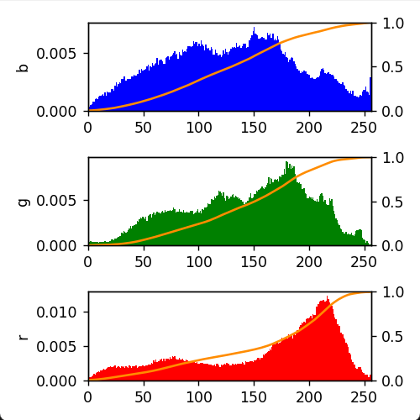 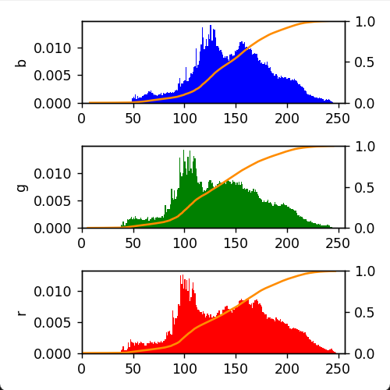

# 灰度变换  
# TwoSegment0  
# FourSegment0  
cvBGRAdjust0(dogImg, "dogImg0-TwoSegment0", f=TwoSegment0)  
cvBGRAdjust0(dogImg, "dogImg0-FourSegment0", f=FourSegment0)

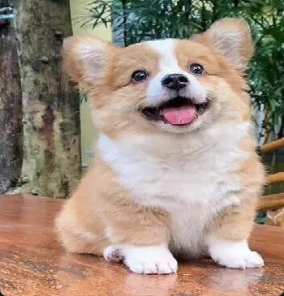 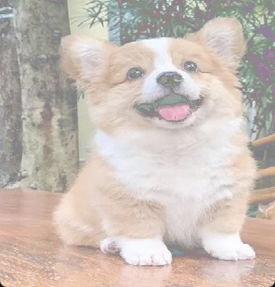 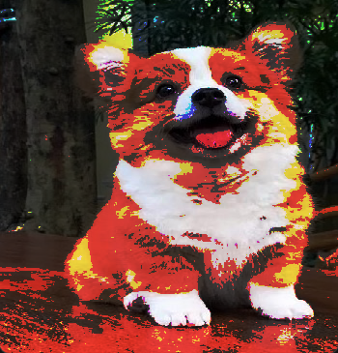

# 非线性灰度变换  
# pow0  
# pow1  
# sigmoid0  
# sigmoid1  
# logic0  
# logic1  
# s0  
cvBGRAdjust1(dogImg, "dogImg1-pow0", f=pow0)  
cvBGRAdjust1(dogImg, "dogImg1-pow1", f=pow1)  
cvBGRAdjust1(dogImg, "dogImg1-sigmoid0", f=sigmoid0)  
cvBGRAdjust1(dogImg, "dogImg1-sigmoid1", f=sigmoid1)  
cvBGRAdjust1(dogImg, "dogImg1-logic0", f=logic0)  
cvBGRAdjust1(dogImg, "dogImg1-logic1", f=logic1)  
cvBGRAdjust1(dogImg, "dogImg1-s0", f=s0)

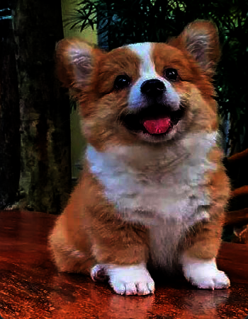

1697209595624

# 直方图规定化  
# 参考infer_map给img_org配色  
get_hist_match(dogImg, catImg)  
get_hist_match(catImg, dogImg)

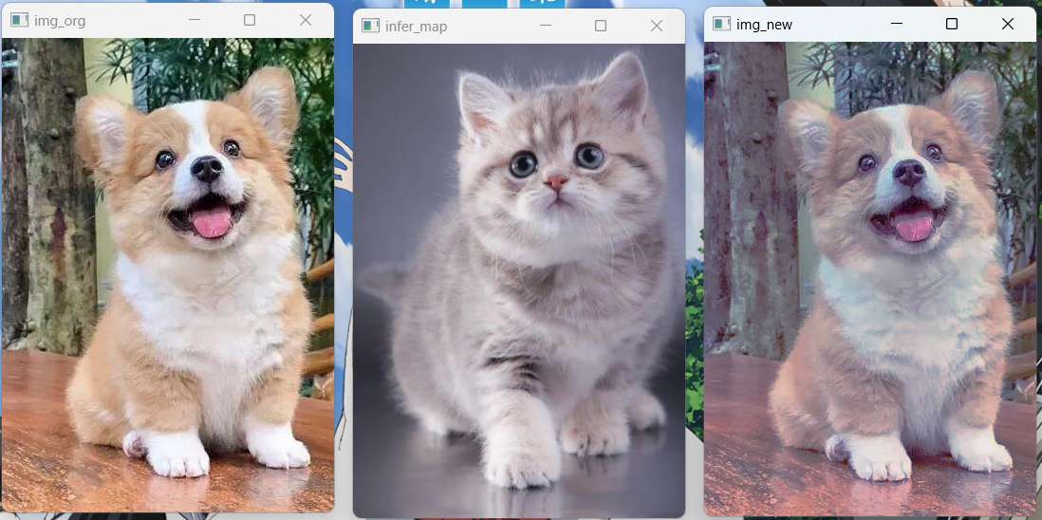 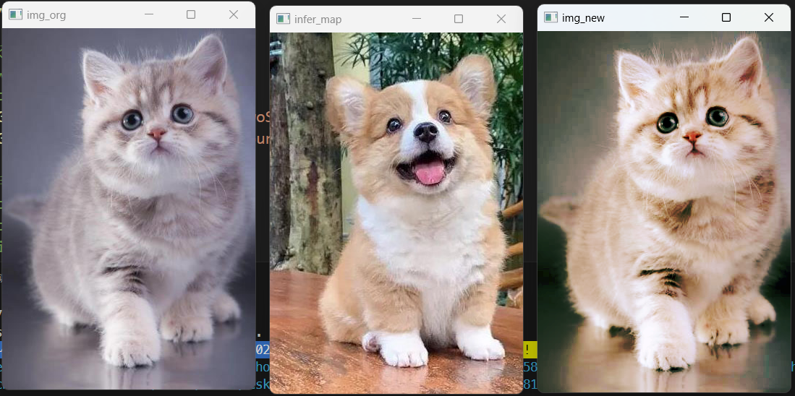

# 显示频谱图  
spectrum_show(dogImg)  
spectrum_show(catImg)

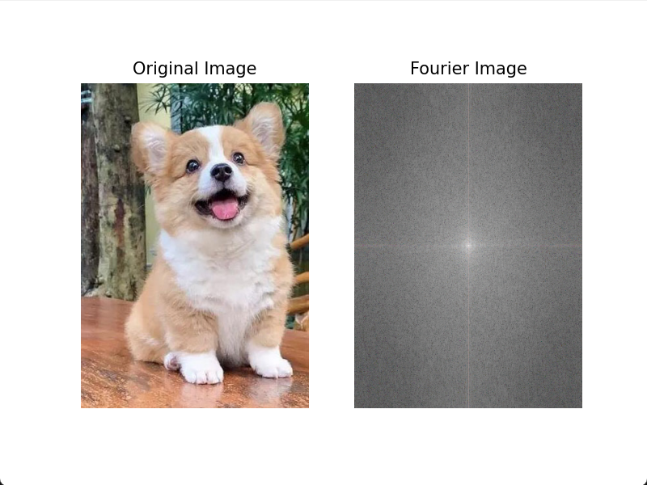 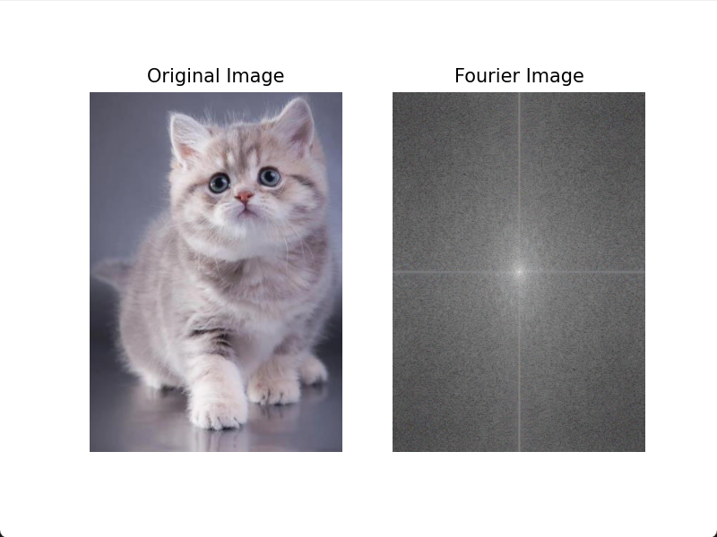

# 频域滤波  
# cal_distance  
# IdealLowPass  
# ButterworthLowPass  
# GaussianLowPass  
# IdealhighPass  
# ButterworthhighPass  
# GaussianhighPass  
# GaussianhighPassEmphasize  
spectralFilter(dogImg, f=cal_distance)  
spectralFilter(dogImg, f=IdealLowPass)  
spectralFilter(dogImg, f=ButterworthLowPass)  
spectralFilter(dogImg, f=GaussianLowPass)  
spectralFilter(dogImg, f=IdealhighPass)  
spectralFilter(dogImg, f=ButterworthhighPass)  
spectralFilter(dogImg, f=GaussianhighPass)  
spectralFilter(dogImg, f=GaussianhighPassEmphasize)  
  
  
# 同态滤波  
homomorphic_filter(dogImg)  
homomorphic_filter(catImg)  
  
homomorphic_filter_HSL(dogImg)  
homomorphic_filter_HSL(catImg)

# 伪彩色着色  
flower = cv2.imread("./imgs/flower.jpg")  
pseudocolorFlower(flower)  
  
# 色彩变换  
cvHSLAdjust0(dogImg, "dogImg0-HSLAdjust0")  
cvHSLAdjust1(dogImg, "dogImg1-HSLAdjust1")  
cvHSLAdjust2(dogImg, "dogImg2-HSLAdjust2")

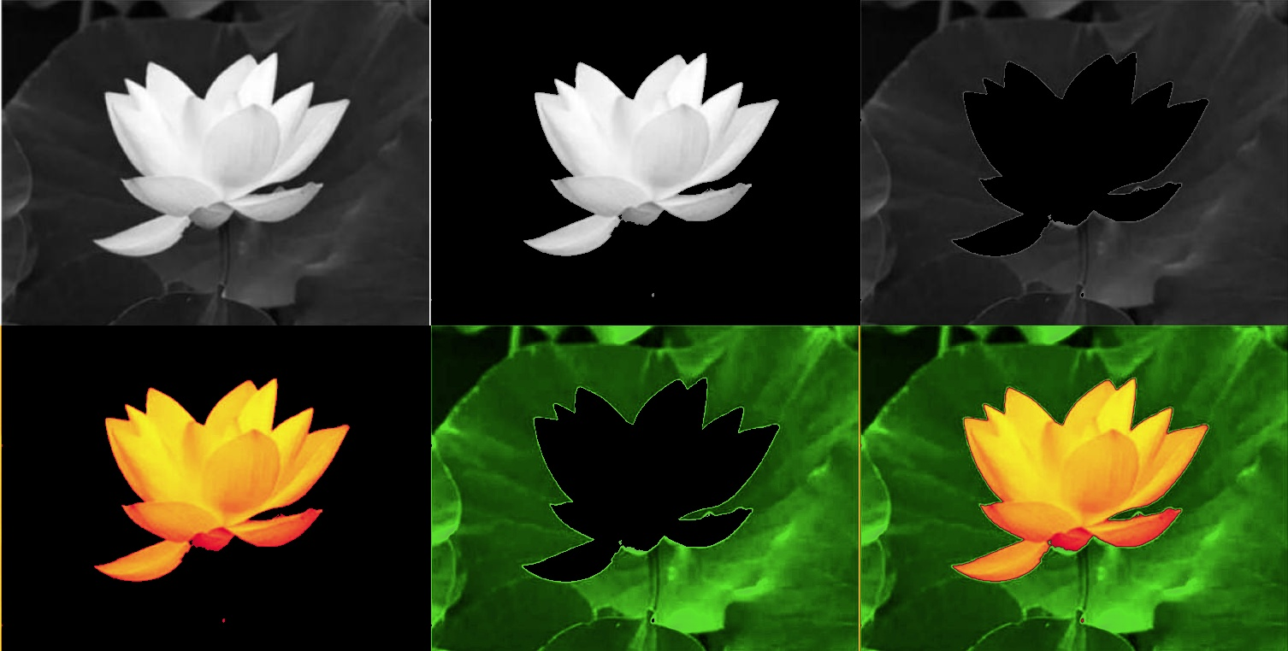 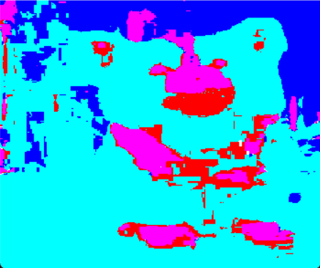

联合几何变换类和颜色变换类方法，为同一张图片进行数据扩充，部分代码及图片展示如下：

import cv2  
import numpy as np  
  
# 读取图片  
img = cv2.imread("./imgs/cat.jpg")  
  
# 几何变换  
rows, cols, _ = img.shape  
M = cv2.getRotationMatrix2D((cols / 2, rows / 2), 30, 1)  
img_rotate = cv2.warpAffine(img, M, (cols, rows))  
img_flip = cv2.flip(img, 1)  
  
# 颜色变换  
img_hsv = cv2.cvtColor(img, cv2.COLOR_BGR2HSV)  
img_h, img_s, img_v = cv2.split(img_hsv)  
img_h = cv2.equalizeHist(img_h)  
img_s = cv2.equalizeHist(img_s)  
img_v = cv2.equalizeHist(img_v)  
img_hsv_eq = cv2.merge([img_h, img_s, img_v])  
img_gray = cv2.cvtColor(img, cv2.COLOR_BGR2GRAY)  
img_gray_eq = cv2.equalizeHist(img_gray)  
  
# 显示结果  
cv2.imshow("Original", img)  
cv2.imshow("Rotated", img_rotate)  
cv2.imshow("Flipped", img_flip)  
cv2.imshow("HSV Equalized", cv2.cvtColor(img_hsv_eq, cv2.COLOR_HSV2BGR))  
cv2.imshow("Gray Equalized", cv2.cvtColor(img_gray_eq, cv2.COLOR_GRAY2BGR))  
cv2.waitKey(0)  
cv2.destroyAllWindows()

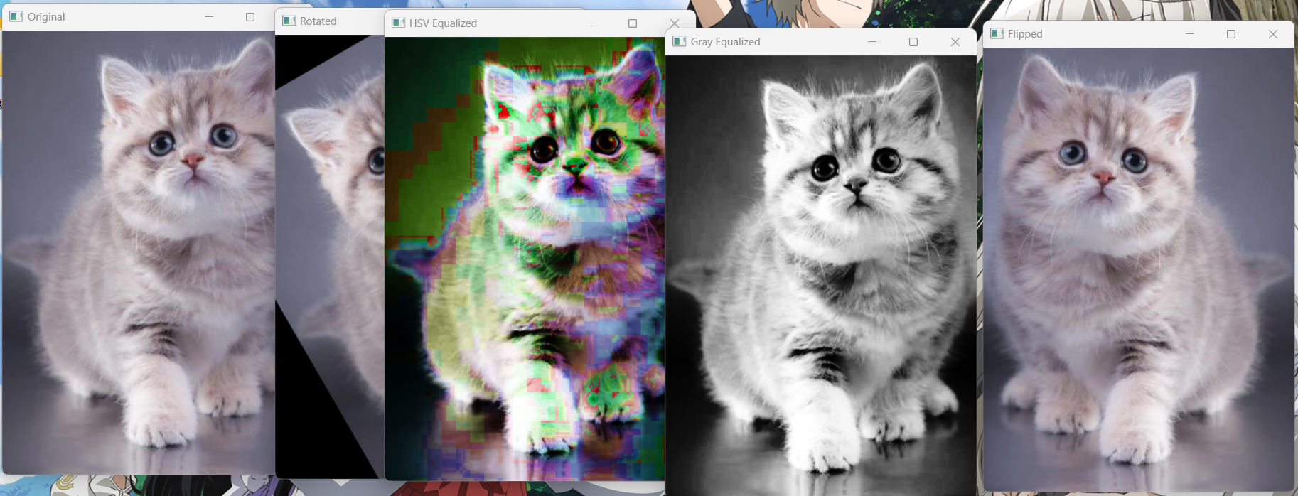

1697210085980

import cv2  
import numpy as np  
from util import *  
  
# 加载图片  
img = cv2.imread("./imgs/cat.jpg")  
  
# 几何变换  
rows, cols, _ = img.shape  
M = cv2.getRotationMatrix2D((cols / 2, rows / 2), 30, 1)  
img_rotate = cv2.warpAffine(img, M, (cols, rows))  
img_flip = cv2.flip(img, 1)  
  
# 颜色变换  
img_hsv = cv2.cvtColor(img, cv2.COLOR_BGR2HSV)  
img_h, img_s, img_v = cv2.split(img_hsv)  
img_h = cv2.equalizeHist(img_h)  
img_s = cv2.equalizeHist(img_s)  
img_v = cv2.equalizeHist(img_v)  
img_hsv_eq = cv2.merge([img_h, img_s, img_v])  
img_gray = cv2.cvtColor(img, cv2.COLOR_BGR2GRAY)  
img_gray_eq = cv2.equalizeHist(img_gray)  
  
# 数据扩充  
cvBGRAdjust0(img, "img-TwoSegment0", f=TwoSegment0)  
cvBGRAdjust0(img, "img-FourSegment0", f=FourSegment0)  
cvBGRAdjust0(img, "img-pow0", f=pow0)  
cvBGRAdjust0(img, "img-pow1", f=pow1)  
cvBGRAdjust0(img, "img-sigmoid0", f=sigmoid0)  
cvBGRAdjust0(img, "img-sigmoid1", f=sigmoid1)  
cvBGRAdjust0(img_rotate, "img_rotate-TwoSegment0", f=TwoSegment0)  
cvBGRAdjust0(img_rotate, "img_rotate-FourSegment0", f=FourSegment0)  
cvBGRAdjust0(img_rotate, "img_rotate-pow0", f=pow0)  
cvBGRAdjust0(img_rotate, "img_rotate-pow1", f=pow1)  
cvBGRAdjust0(img_rotate, "img_rotate-sigmoid0", f=sigmoid0)  
cvBGRAdjust0(img_rotate, "img_rotate-sigmoid1", f=sigmoid1)  
cvBGRAdjust0(img_flip, "img_flip-TwoSegment0", f=TwoSegment0)  
cvBGRAdjust0(img_flip, "img_flip-FourSegment0", f=FourSegment0)  
cvBGRAdjust0(img_flip, "img_flip-pow0", f=pow0)  
cvBGRAdjust0(img_flip, "img_flip-pow1", f=pow1)  
cvBGRAdjust0(img_flip, "img_flip-sigmoid0", f=sigmoid0)  
cvBGRAdjust0(img_flip, "img_flip-sigmoid1", f=sigmoid1)  
cvBGRAdjust0(img_hsv_eq, "img_hsv_eq-TwoSegment0", f=TwoSegment0)  
cvBGRAdjust0(img_hsv_eq, "img_hsv_eq-FourSegment0", f=FourSegment0)  
cvBGRAdjust0(img_hsv_eq, "img_hsv_eq-pow0", f=pow0)  
cvBGRAdjust0(img_hsv_eq, "img_hsv_eq-pow1", f=pow1)  
cvBGRAdjust0(img_hsv_eq, "img_hsv_eq-sigmoid0", f=sigmoid0)  
cvBGRAdjust0(img_hsv_eq, "img_hsv_eq-sigmoid1", f=sigmoid1)  
cvBGRAdjust0(img_gray_eq, "img_gray_eq-TwoSegment0", f=TwoSegment0)  
cvBGRAdjust0(img_gray_eq, "img_gray_eq-FourSegment0", f=FourSegment0)  
cvBGRAdjust0(img_gray_eq, "img_gray_eq-pow0", f=pow0)  
cvBGRAdjust0(img_gray_eq, "img_gray_eq-pow1", f=pow1)  
cvBGRAdjust0(img_gray_eq, "img_gray_eq-sigmoid0", f=sigmoid0)  
cvBGRAdjust0(img_gray_eq, "img_gray_eq-sigmoid1", f=sigmoid1)  
  
# 显示结果  
cv2.imshow("Original", img)  
cv2.imshow("Rotated", img_rotate)  
cv2.imshow("Flipped", img_flip)  
cv2.imshow("HSV Equalized", cv2.cvtColor(img_hsv_eq, cv2.COLOR_HSV2BGR))  
cv2.imshow("Gray Equalized", cv2.cvtColor(img_gray_eq, cv2.COLOR_GRAY2BGR))  
cv2.waitKey(0)  
cv2.destroyAllWindows()

1. **实验总结**

**本次实验，我选用了一张猫、狗和花朵的图片，参考课件中给出的代码通过灰度变换、直方图规定化、频域滤波、伪彩色着色等方法对图像进行了增强。其中直方图规定化参考配色这一部分我觉得非常的有趣，只需要简单的变换就将一张图片的变成了另一张图片的风格。**

**通过查阅资料和编码实验，不同的图像增强方式拥有不同的作用，如线性灰度变换主要作用是拉开图像的对比度，让图像中黑的地方更黑，亮的地方更亮。非线性灰度变换则可以有选择性地增强低灰度区域的对比度或是高灰度区域的对比度。**

1. **材料提交**

1.实验要求内容完备(实验代码、实验结果及分析)、格式规范、排版美观。

2.实验过程中遇到问题需记录具体问题和解决方法；

3.把相关材料(包括实验报告、实验代码、实验使用到的图片等数据)压缩打包为“计算机视觉实验06_学号_姓名.zip”，提交到邮箱pengshenglin@nwu.edu.cn；

4.截止时间为实验课当周周日24点前(如实验课在周六周日，截止时间为下周周二24点前)。

5.不要迟交，不要抄袭(迟交当次作业最多70分，抄袭整个课程记0分！)。实验报告整体雷同且存在以下情况判为抄袭：程序仅有极少字符与变量的不同且；程序仅有空格和分行的不同；存在从网页复制导致的乱码，全角符号，非ASCII符号，&nbsp;等；代码高度相似并且程序存在完全相同的错误。(重复教材上的代码不计入抄袭)